**Facial Recognition Based Attendance System**

# System Description of the Facial Recognition Attendance System

**1. System Components:**

* **Hardware Components:**
* **ESP32-S3 Microcontroller:**
  + A robust microcontroller with built-in Wi-Fi and Bluetooth capabilities, tailored for AI and IoT applications. It serves as the central processing unit for the system.
* **Camera:**
  + A high-resolution camera attached to the ESP32-S3 captures facial images of users for recognition purposes. The camera ensures clear and detailed image acquisition.
* **TFT RGB565 Screen:**
  + A colour display screen that provides visual feedback to users. It displays instructions, recognition results, and other relevant information.
* **RTC Clock:**
* For maintaining accurate timestamp for each event data.
* **Flash Memory:** use for storing device info data , person data, log, etc
* **Software Component:**
* **Dedicated Server:**
  + A secure server dedicated solely to this application. It receives, stores, and manages real-time event data sent from the client (attendance & mobile) devices.
* **Mobile Application:**
* There will be a single mobile application which will assist two separate user group of the customer which will be decided using login access credentials.

1. System Admin User – this group of users will be able to configure the system application, devices and view admin state reports and other controlling features.
2. General User: This group of users will only be able to see their respective event logs. (Monthly reports, attendance data Etc.)

**2. System Feature List:**

1. Easy management from mobile application for both admin and user.

2. Employee information management, Attendance management, Shift management, leave management can be performed easily from mobile application.

3. Periodical report generation feature is available. Daily real-time attendance overview feature is also there.

**3. System Workflow:**

When a user approaches the device, the camera captures an image of their face. Based on this captured image, below mentioned operations will take palce:

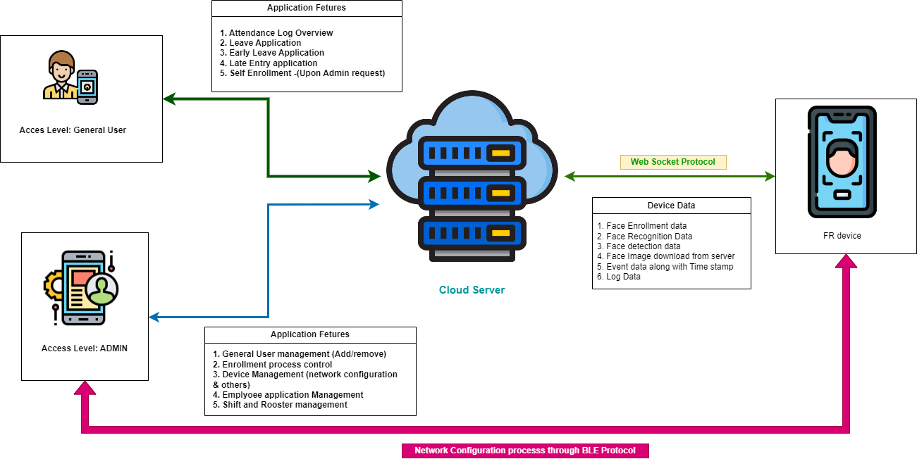

* **Local Processing:**
  + The ESP32-S3 processes the captured image to detect and recognize the face. This involves several steps:
    - **Face Detection:** Identifying the presence of a face in the captured image.
    - **Face Recognition:** Comparing the detected face with a pre-stored database of faces to find a match.
* **Recognition Feedback:**
  + The TFT screen displays the recognition result to the user. If the face is recognized, the screen shows a success message along with the user's name or ID. If not, it prompts the user to try again.
* **Data Logging and Communication:**
  + Upon successful recognition, the ESP32-S3 logs the event (including the user ID and timestamp) and securely transmits this data to the dedicated server in real-time.

**Normal Operation:**

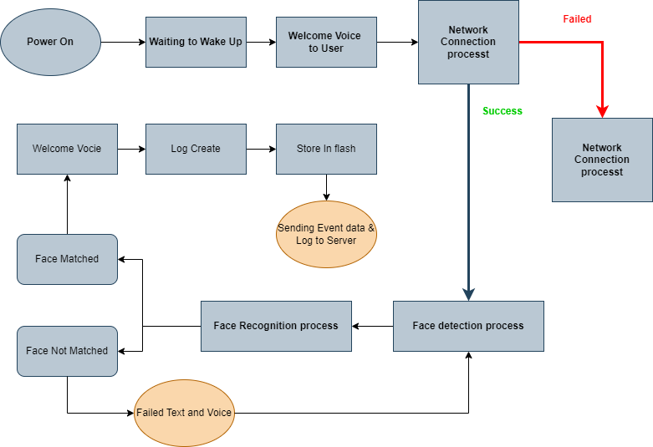

**Wi-Fi:**

**Face Recognition:**

**Self-Enrolment:**

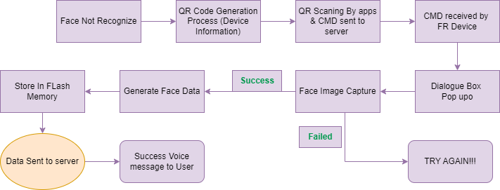

**3. Device Functionality:**

**Network configuring:**

1. Enable Bluetooth on your phone and scan the device's QR code using the mobile application
2. On the Bluetooth Discovery screen, select the detected device. Make sure the Serial Number (SN) on the device matches the one displayed on the app

1. After selecting the device, you will be directed to the Select Network screen. Here, you can choose to connect to an existing Wi-Fi network or manually enter the Wi-Fi information.
2. Once the device prompts “Bluetooth network configuration successful,” the device pairing is complete.

**Binding a Device:**

Once the device is successfully connected to the network, the interface will jump to

the "Device Details" page. Set the available information, then the device prompts "Bind successful, data syncing.

**Add Person:** an admin to add a person to a specific group or department.

**Enrol Facial Information:** Search for members by name, group or department to enrol their facial information.

1. Select a member and tap "Enter Facial Information - Enrol on Device". A pop-up window will appear with instructions. When the device prompts "Please look directly at the camera, keep your face in the centre position", follow the instructions. Once prompted "Enrolment successful", facial recording is complete
2. **Self-Enrolment:**
   1. The administrator needs to enable "Enable Self-Enrolment Facial Information. If an employee's face is not recognized by the device, a "Face Not Registered" message will pop up. On the top right corner of the screen along with a "Scan QR Code for Self-Enrolment" QR code. Employees can use the mobile app to scan this QR code to self-enrol their facial information on the device

* 1. Admin selects employees and sends them an enrolment link via SMS/Email. employees can simply click on the link in the SMS to open the "Upload Facial Information" interface and follow the instructions to take photos for enrolment.

**Log Handling:** First, we can follow this data packet format and later it can be improved as per our requirement.

**Log Generating:**

**Attendance:** log type + device time + person id

**Time:** log type + time

**Log Storing:** device time + person id

**Log Handle with server:**

**Enrolment log tx:** log type + log+ person Name + Id + welcome text + SN

**Enrolment log rx:** log type + log + person Name + id + welcome text +SN

**Attendance log:** log type + device time + log time + person id + SN

**Time log:** log type + time + SN